**MODULE: 1**

1. What is software? What is software engineering?
2. Software is a set of instructions , data or programs used to operate computers and excute specific tasks. . It can be categorized into two main types:

* System Software: This includes the operating system and utility programs that manage computer hardware and provide a platform for application software.
* Application Software: These are programs designed for end-users to perform specific tasks, like word processing, web browsing, or graphic design.

Software engineering is the branch of computer science that deals with the design, development, testing and maintenance of software applications. . It involves:

* Requirements Analysis: Understanding what the software needs to accomplish.
* Design: Creating a blueprint for how the software will work.
* Implementation: Writing the actual code.
* Testing: Ensuring the software functions as intended and is free of defects.
* Maintenance: Updating and fixing software after it has been deployed.

1. Explain types of software
2. Types of Software are Application Software, System Software, Driver Software, Middleware, Programming Software.

* Application Software:
* Productivity Software: Helps users perform tasks (e.g., Microsoft Office, Google Docs).
* Graphics Software: Used for creating and editing images (e.g., Adobe Photoshop, CorelDRAW).
* Web Browsers: Enable access to the internet (e.g., Chrome, Firefox).
* Database Software: Manage and organize data (e.g., MySQL, Oracle).
* Communication Software: Facilitate communication (e.g., Slack, Zoom).
* System Software
* Operating Systems (OS): Manage hardware and software resources (e.g., Windows, macOS, Linux).
* Utility Software: Perform maintenance tasks (e.g., antivirus programs, disk management tools).
* Driver Software:
* Also known as device dirvers. This software is often considered a type of system software
* Device drivers control the devices and peripherals connected to a computer, enabling them to perform their pecific tasks.
* Every device that is connected to a computer needs atleast one device driver to function.
* Examples include software that comes with any non standard hardware including special game controllers as well as the software that enables standard hardware such as USB storage devices, keyboards, headphones and printers. Eg: Audio Driver, Video Driver etc.
* Middleware Software
* The term middle ware describes software that mediates between application and system software or between two different kinds of application software. For eg: middleware enables Microsoft Windows to talk to Excel and Word.
* It is also used to send a remote work request from application in a computer with a different OS. It also enablesnewer applications to work with legacy ones. Eg: Database Middleware, application server middleware.
* Programming Software
* Computer programmers use programming software to write code. Programming software and programming tools enable developers to develop, write, test and debug other software programs.
* Examples of programing software include assemblers, compilers, debuggers and interpretors. Eg: Turbo, eEclipse, Sublime etc.

1. What is SDLC? Explain each phase of SDLC
2. The Software Development Life Cycle refers to an methodology with clearly defined process for creating high quality software.
3. Planning
4. Analysis
5. Design
6. Implementation
7. Testing & Integration
8. Maintainence
9. What is DFD? Create a DFD diagram on Flipkart
10. A Data Flow Diagram is a graphical or visual representation that uses a standardized set of symbols and notations to describe business operations through data movement.

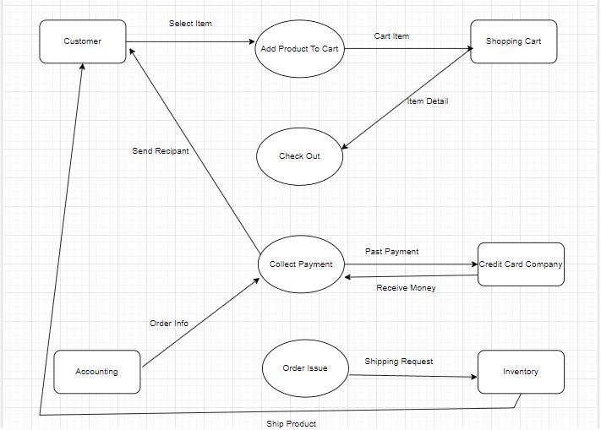

1. What is Flow chart? Create a flowchart to make addition of two numbers
2. A flow chart is a visual representation of a process or workflow. It uses standardized symbols, such as ovals, rectangles, diamonds, and arrows, to illustrate the steps involved and the sequence of actions. Flow charts help simplify complex processes, making it easier to understand, analyze, and communicate how a task is completed or how information flows within a system. They're commonly used in various fields, including business, engineering, and education, to enhance clarity and efficiency.

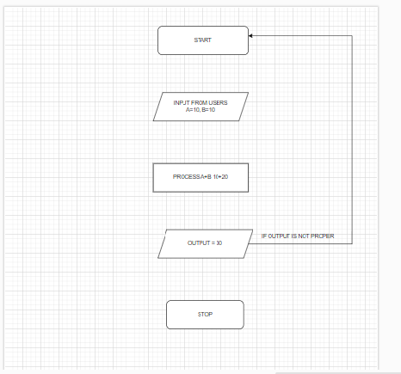

6. What is Use case Diagram? Create a use-case on bill payment on paytm.

A. A use case diagram is a type of visual representation used in software engineering to illustrate the interactions between users (or "actors") and a system. It focuses on the functional requirements of the system by depicting various use cases—specific scenarios in which the system is utilized.

